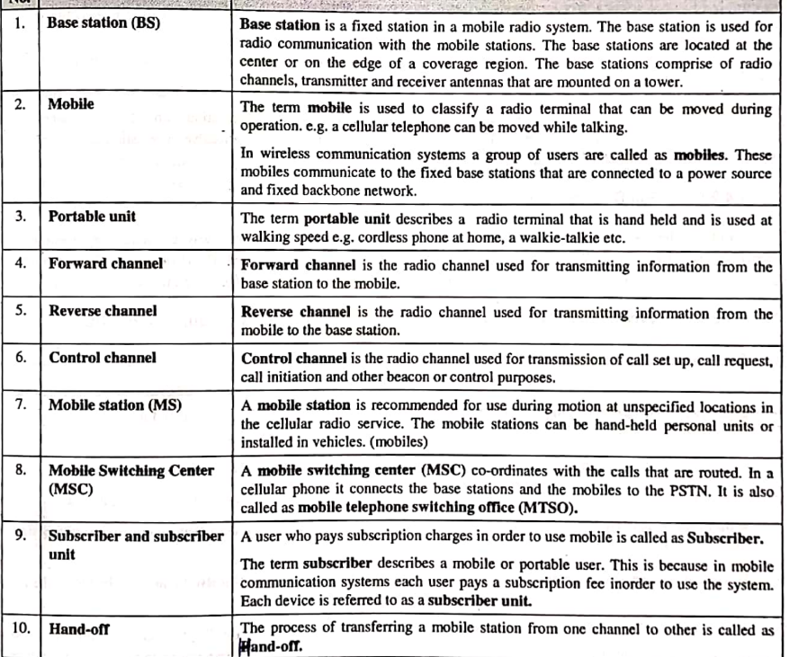

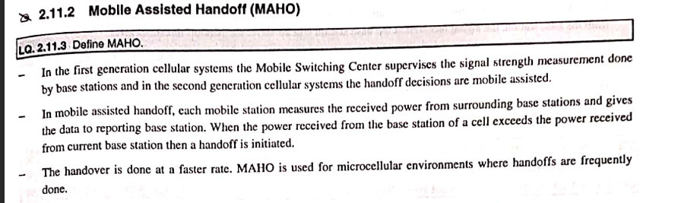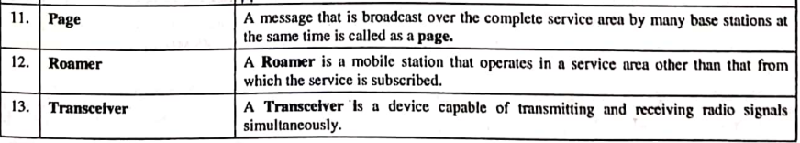

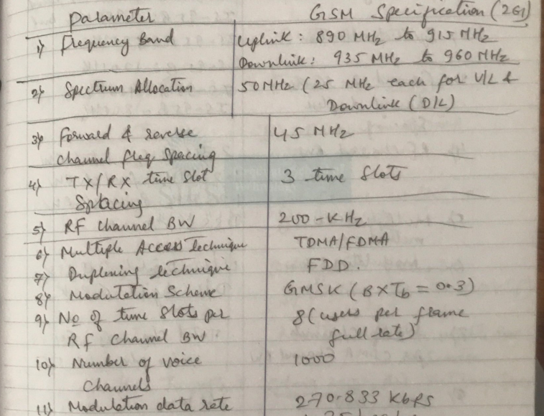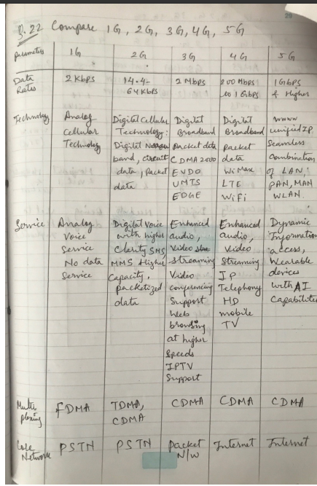





And circuit switching



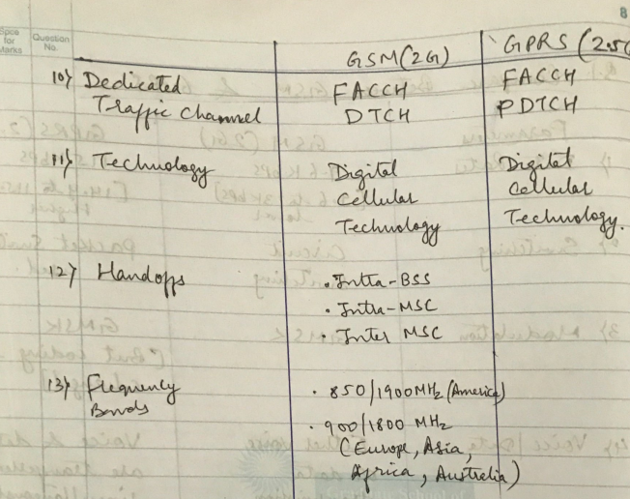

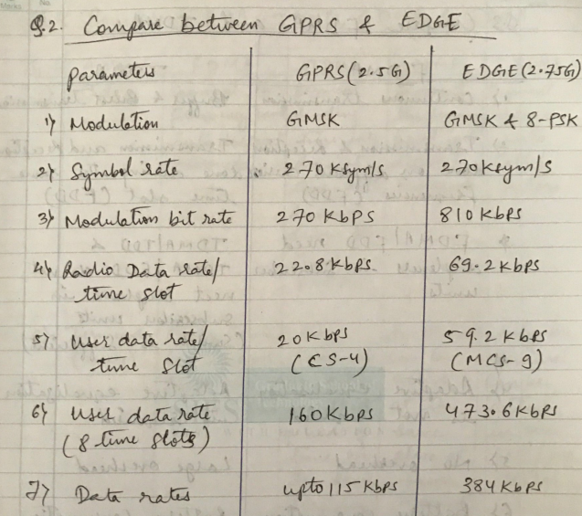



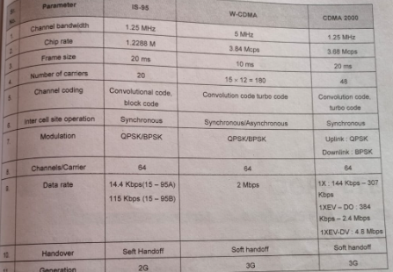



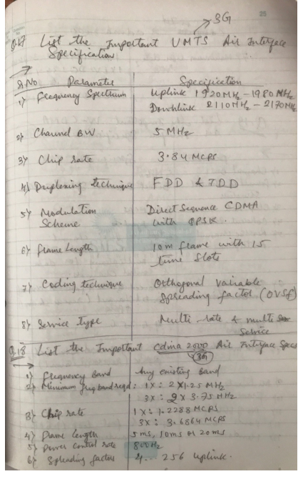

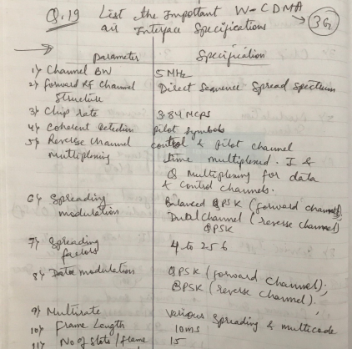

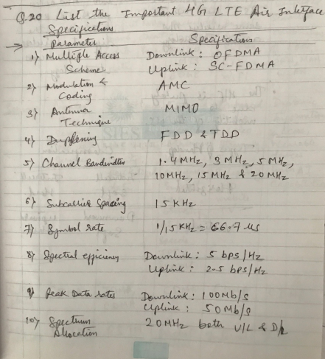

**Features of 5G**

1. Higher Data Rates: 5G aims to provide significantly faster data rates compared to previous generations, supporting multi-gigabit-per-second speeds.
2. Low Latency: 5G networks target ultra-low latency, reducing the delay in data transmission, crucial for real-time applications like augmented reality, virtual reality, and autonomous vehicles.
3. Increased Network Capacity: 5G is designed to accommodate a higher number of connected devices per unit area, addressing the growing demand for device connectivity.
4. Improved Spectral Efficiency: 5G utilizes advanced technologies such as Massive MIMO and beamforming to enhance the efficiency of spectrum utilization, allowing more data to be transmitted over the available frequency bands.
5. Network Slicing: This feature enables the creation of virtual networks tailored to specific use cases or applications, optimizing the network for different requirements simultaneously.
6. Massive IoT Connectivity: 5G supports a massive number of simultaneous connections, making it suitable for the Internet of Things (IoT) and machine-to-machine communication.
7. Energy Efficiency: 5G networks aim to be more energy-efficient, contributing to sustainability goals and reducing operational costs.

